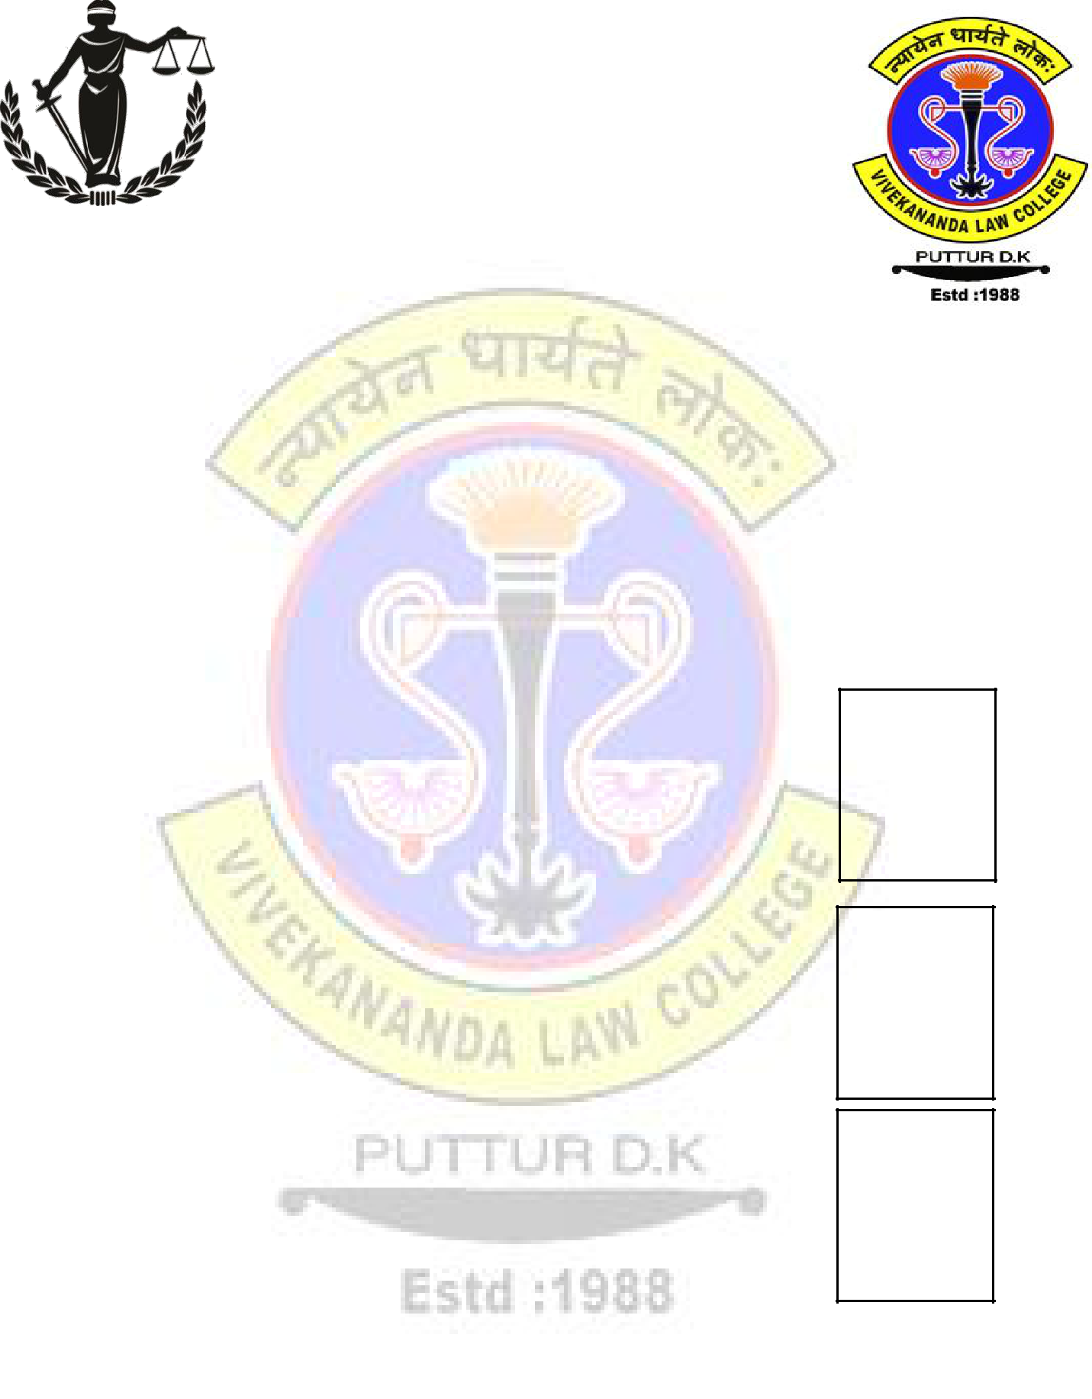
VIVEKANDA LAW COLLEGE,
Puttur, Karnataka

SECOND ALL INDIA
MOOT COURT COMPETITION

DATE: 21st – 23rd February 2020

REGISTRATION FORM

- Name and Address of the participating institution: -

_________________________________________

_________________________________________

_________________________________________

_________________________________________

- Name of the participant(s) and their Role

  - Speaker1 Name-

Year and Course of Study-Phone number and Email id-

  - Speaker2 Name-

Year and Course of Study-Phone number and Email id-

  - Researcher Name-
Year and Course of Study-Phone number and Email id-

3. Faculty In-charge- ____________________

Designation- ____________________

Phone Number- ____________________

Email id- ____________________

Speaker 1

Affix your latest Passport size Photograph here & Sign across

Speaker 2

Affix your latest Stamp size Photograph here & Sign across

Researcher

Affix your latest Stamp size Photograph here & Sign across

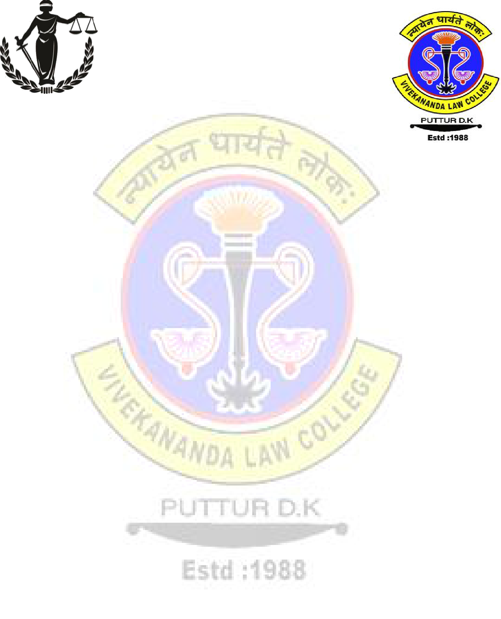
VIVEKANDA LAW COLLEGE
Puttur, Karnataka

SECOND ALL INDIA
MOOT COURT COMPETITION

DATE: 21st – 23rd February 2020

Particulars of Demand Draft

- / Cheque No.__________________________ Date _________________________

Bank Name ______________________ Branch ________________________

NEFT Details: SB Account Number: 8613101000089
Name: Vivekananda Law College, D.K
IFSC: CNRB0008613
Bank: Canara Bank
Branch: NehruNagar

Seal and Signature of the

Head of the Institution

